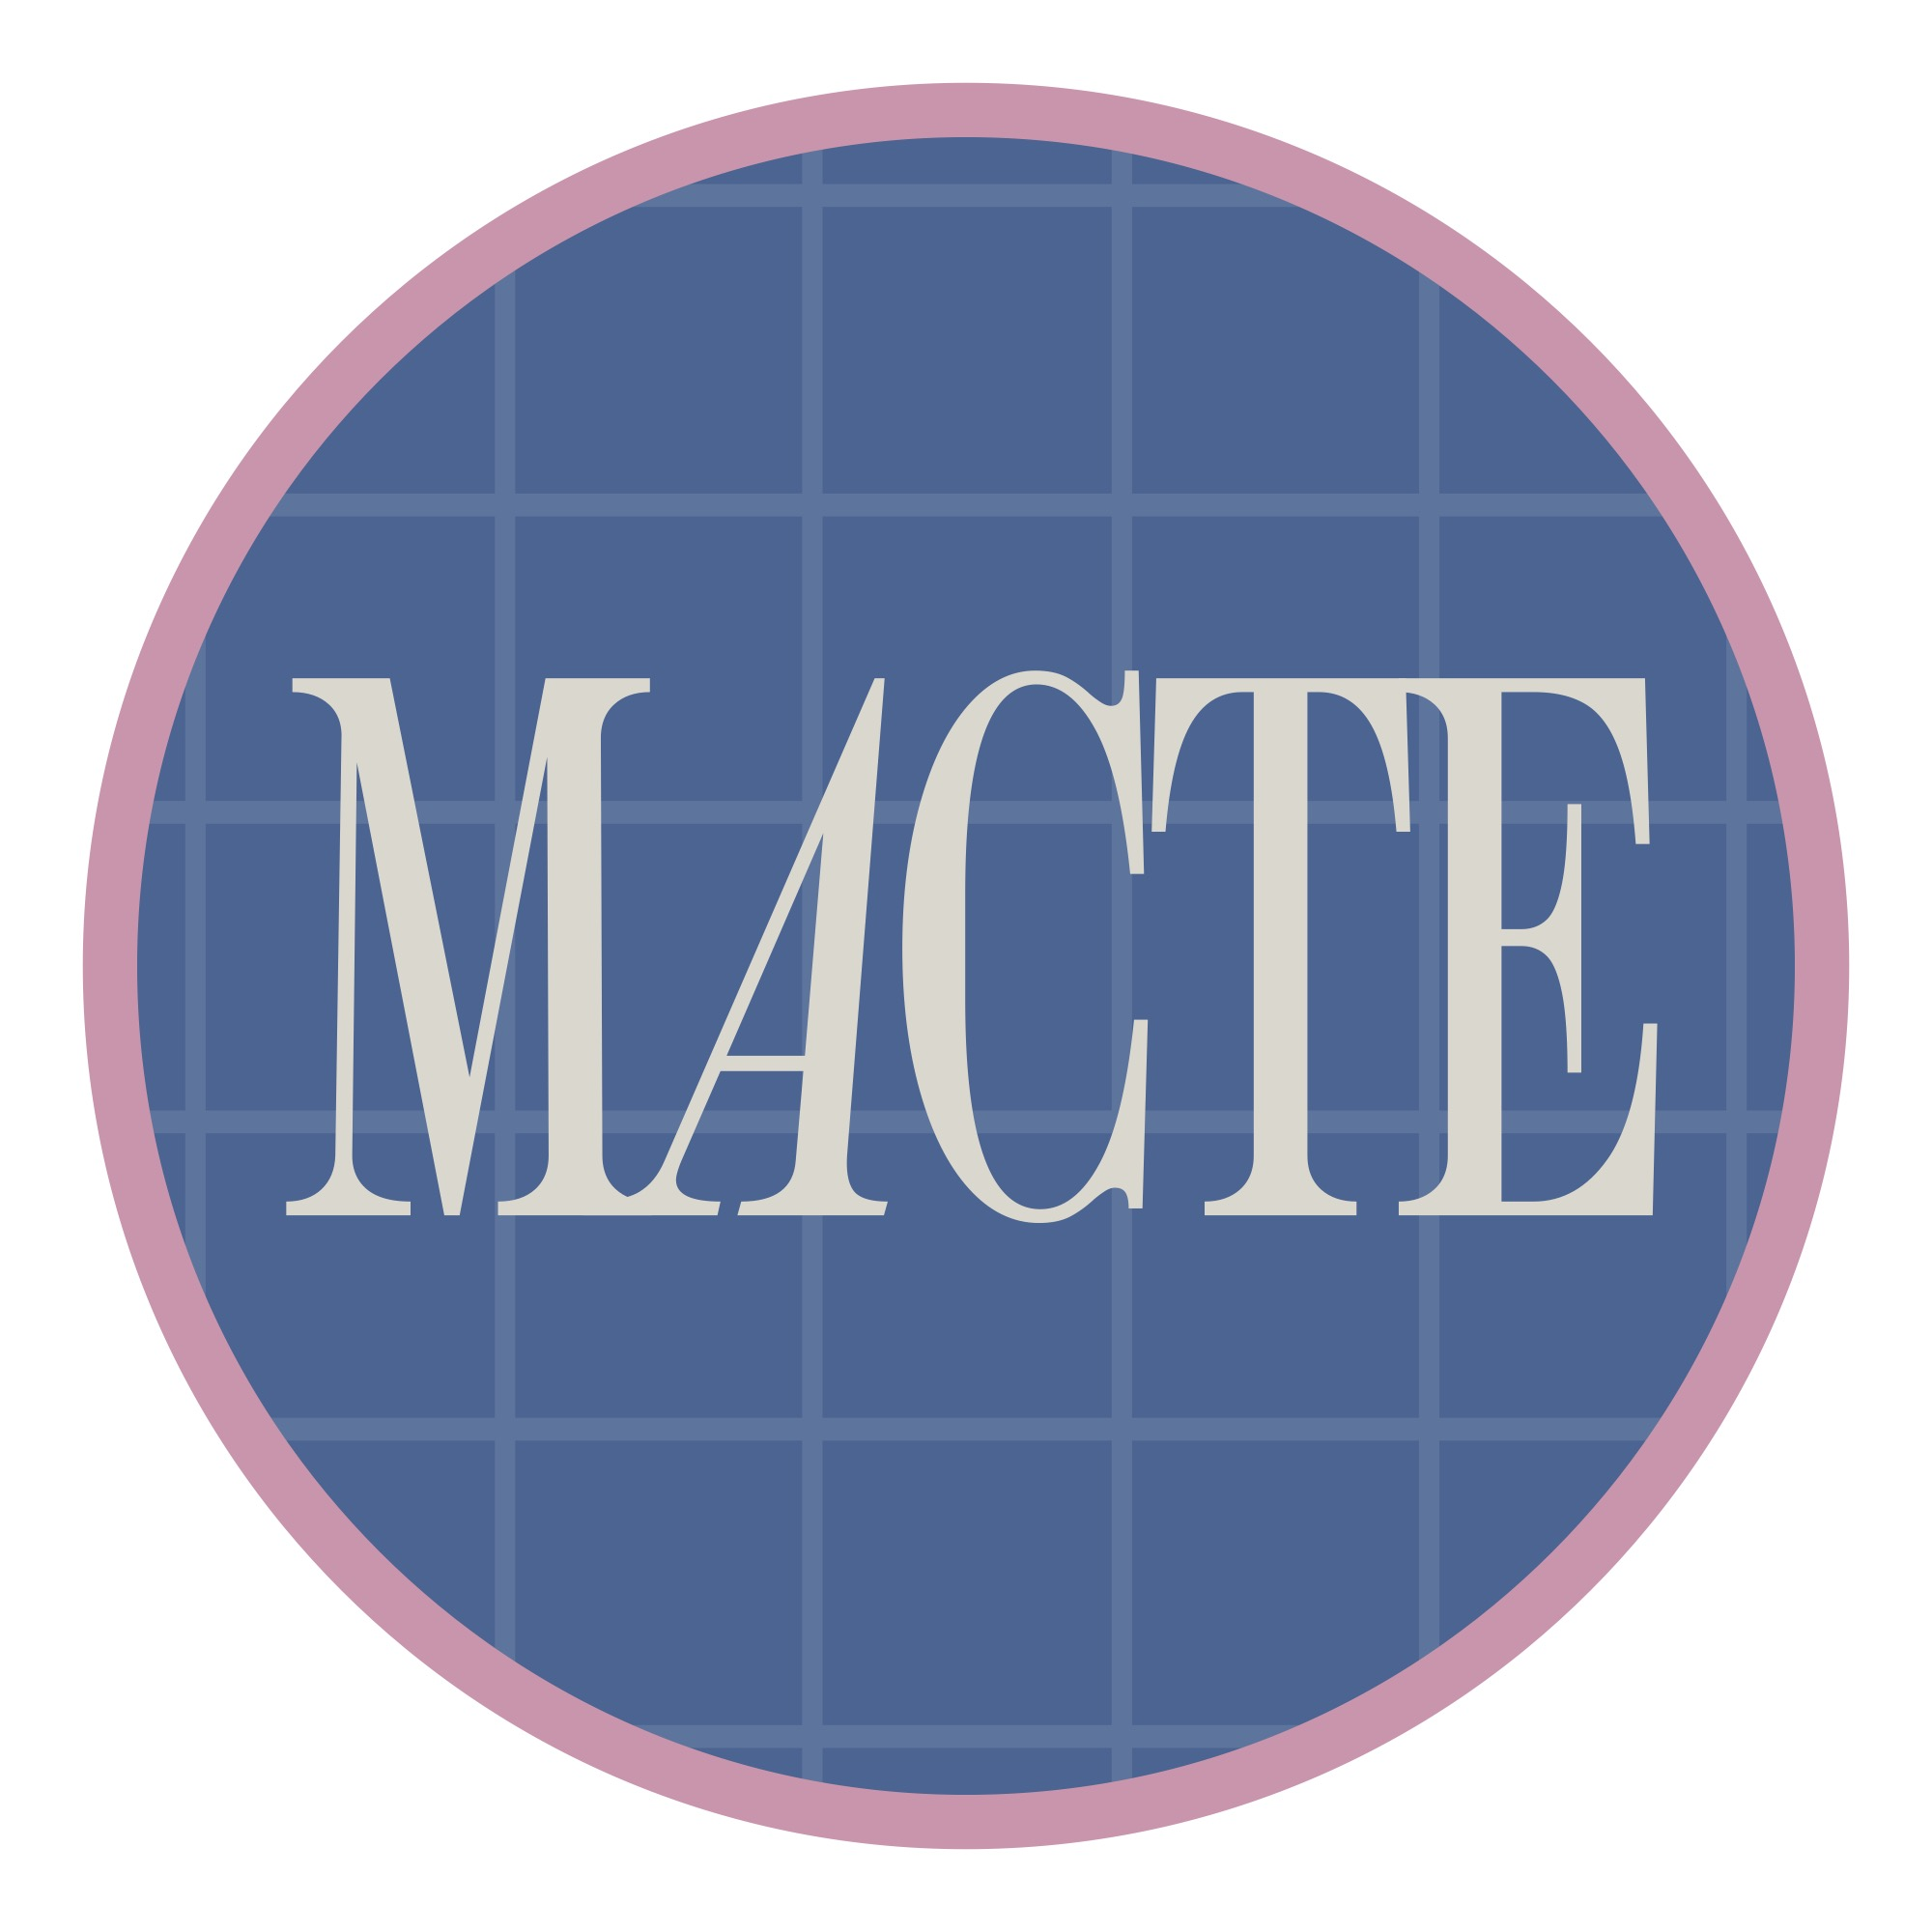

Montessori Accreditation Council for Teacher Education

Professional Development Record Form

Instructions: Complete the Professional Development Record Form for each Program Director, Faculty Member, and/or Field Consultant with all professional development completed in the past three (3) years. Please merge and upload all record forms as a single document to the Program’s Self-Study. If the program’s MRO already utilizes a Professional Development Record Form, you may upload that form to the Self-Study in lieu of this form.

Program Information | Faculty Member Information
Program Name: | Faculty Member Name:
Total Professional Development Hours:
Date of Event  (mm/dd/yyyy) | Description  (Title, Location) | Type of Activity  (Seminar/Workshop, Conference, Certification Course, Other – describe) | Total Hours for Event

