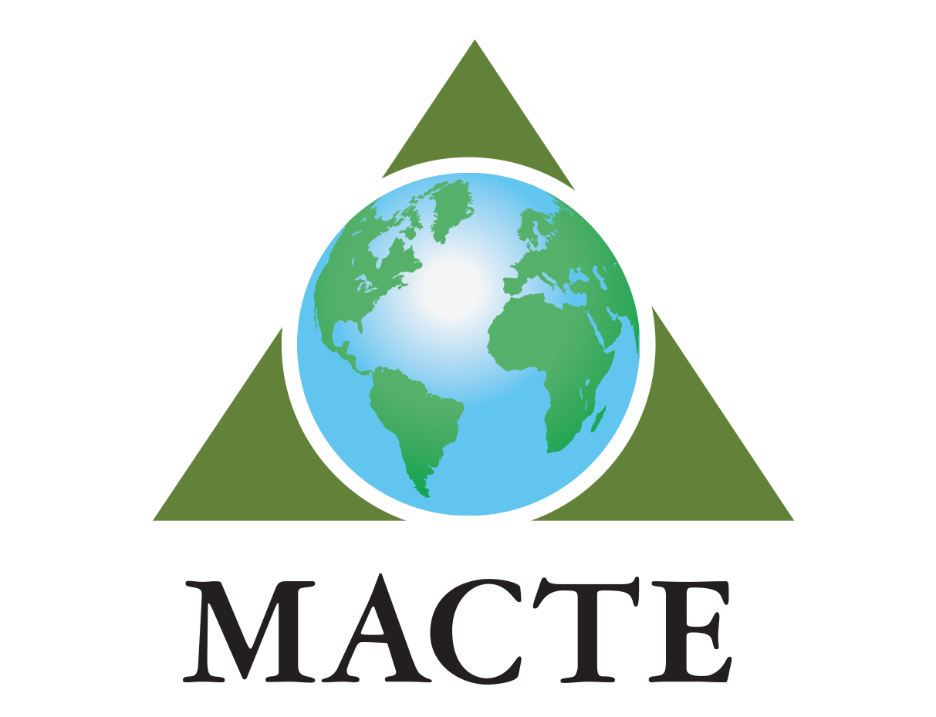

MONTESSORI ACCREDITATION COUNCIL FOR TEACHER EDUCATION

Graduation List

Submission Instructions: This Graduation List should be emailed to info@macte.org when an individual or group of adult learners has completed an accredited course and is ready for credentialing.
Program Information
Program Name:
Address of Location Attended (if same for all adult learners listed):
Adult Learner Name  (Last, First) | Course Level  (IT, EC, EL I, EL I-II, EL II, SEC I, SEC I-II, Admin) | Course Cycle Dates (mm/dd/yy – mm/dd/yy) | Graduation Date | Address of Location(s) Attended  (If varies by adult learner)
(ex.) Doe, Jane | IT | 06/01/202X – 06/01/202X | 03/01/202X | 420 Park Street,  Charlottesville, VA

